Ex.No.-1.1-Design and Draft the given 2D Sketches in modelling software

AIM:

To sketch the given drawing with dimensions using fusion 360 tool

REQUIREMENTS:

- Autodesk fusion 360
- Windows 10
- 16 GB of RAM (integrated graphics recommend 2 GB or more)
- 2.5 Mbps or faster download; 500 Kbps or faster upload

PROCEDURE:

- Open new file and then select sketch icon.
- Select the plane for sketching.
- Use sketching features (Line, circle, arc, polygon, etc.,) to draw the given sketch.
- Establish Centerlines and Origin: Start by drawing the main vertical and horizontal centerlines.Their intersection serves as the origin $(0,0)$ and the center point for the middle profile.
- Sketch the Central Spline/Keyway: Draw a reference circle at the origin based on the Ø 40 dimension. Create the 6 internal lobes by drawing a circle/arc with a radius of R6 and using a circular pattern tool to distribute them symmetrically.
- Locate and Draw the Top Ear: Move vertically upward by 65 units along the vertical centerline to find the top center point. At this point, draw two concentric circles: an inner hole of Ø 20 and an outer arc of Ø 32
- Locate the Symmetric Side Ears: From the central horizontal axis, measure 26 units down. Then, move 47 units to the left and 47 units to the right to locate the precise center points for the two side ears.
- Draw the Side Ear Geometry: At both the left and right side ear center points, draw an inner hole with a radius of R7 and a concentric outer boundary circle with a radius of R10.
- Locate and Draw the Bottom Ear: Measure down an additional 24 units from the side-ear level (a total of 50 units below the origin) along the vertical centerline. Draw an inner hole of Ø 10 and an outer profile of Ø20
- Apply the Large Upper Fillets (R64): Create two large tangent arcs with a radius of R64 on the left and right sides. These arcs must be perfectly tangent to the outer circle of the top ear Ø 32 and blend down into the main body.
- Connect the Upper Part of the Side Ears (R20): Create fillet arcs with a radius of R20 that smoothly connect the lower outer torso of the main body to the top curves of the left and right side ears.
- Blend the Bottom Profiles (R10 & R20): Add the remaining fillet transitions near the bottom. Use a radius of R10 to transition away from the side ears and a radius of R20 to blend smoothly into the bottom ear.
- Trim and Finalize: Use the trim tool to remove all overlapping inner construction lines, cleaning up the profile so that only the solid outer perimeter and the clean inner holes remain.
- After finishing the sketch use finish sketch option to finalize the sketch.
- After finishing the sketch switch to drawing mode to plot the sketch in ISO standard.
RESULT:
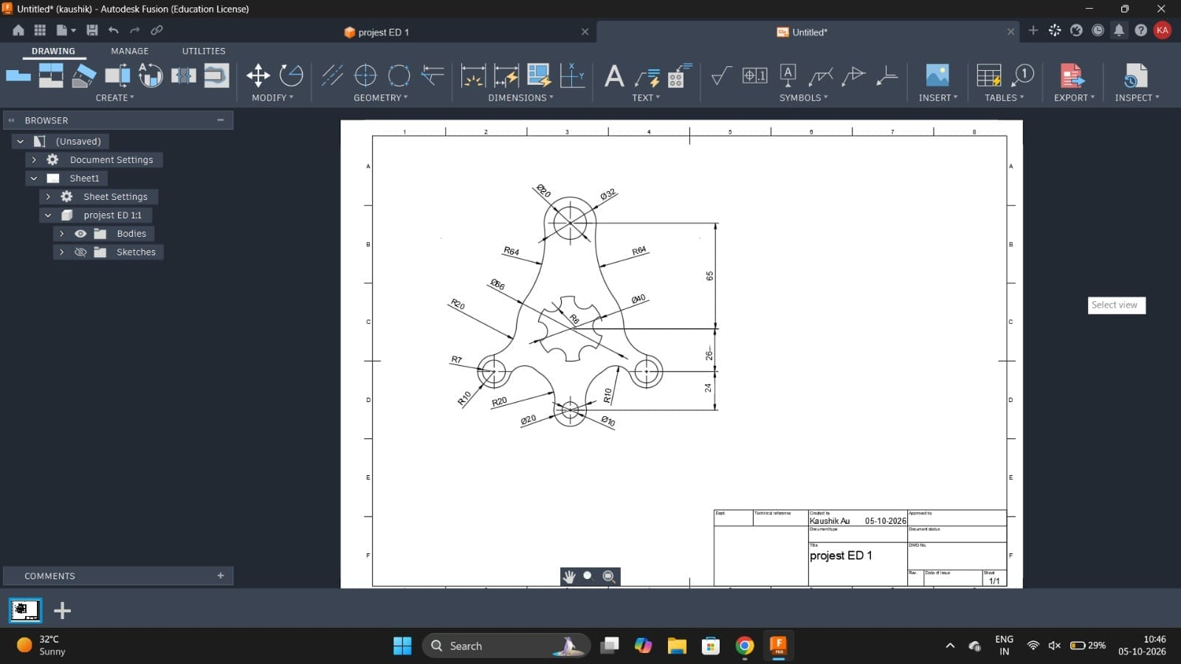
Thus the given sketch is drawn and drafted using fusion 360 tool.

